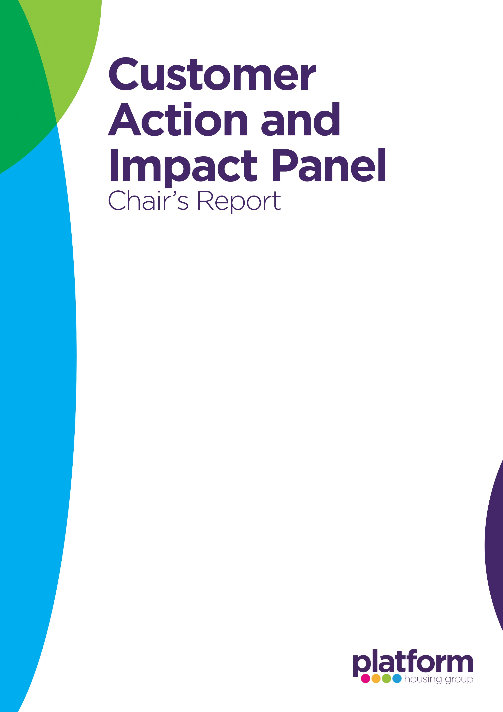
Date of Meeting | 20 August 2026

Topics Discussed & Presenter
Decent Homes Standard Update, Doug Bacon, Deputy Chief Property Officer
Equality, Diversity & Inclusion (EDI) Update, Sarah Baker, Head of Human Resources
Customer Profile Information & Customer First Programme - Kirsty Dyer, Head of EPMO

Observations, Recommendations & Actions
Decent Homes Standard
- Panel members demonstrated a strong interest in how the forthcoming Decent Homes 2 standard will impact customers, particularly regarding flooring standards, damp and mould management, and quality expectations at the start of a tenancy.
- There was positive recognition that Platform is developing an enhanced housing standard above the regulatory minimum and continuing to strengthen stock condition data.
- Members highlighted the importance of transparent processes for recording and completing identified property issues before new tenancies commence.
- Concerns were raised about flooring removal at re-let and the absence of clarity around decision-making, hygiene assessments and record retention.
Recommendations and Actions:
- Consult with customers before determining future flooring standards and incorporate customer expectations into policy development.
- Review and strengthen mechanisms for tracking, evidencing and communicating completion of identified property issues before tenancy commencement.
- Consider developing a formal process for documenting and monitoring promised works during the void and lettings process.
- Ensure future customer communications relating to safety measures, such as window restrictors, are clear and accessible.


Equality, Diversity & Inclusion (EDI)
- Members welcomed the progress made in embedding EDI principles across the organisation, including mandatory Equality Impact Assessments and colleague training.
- Discussion identified opportunities to better understand why some customers choose not to provide feedback and how customer insight can further influence frontline training.
- Members recognised the value of inclusive engagement approaches for customers with vulnerabilities and additional support needs.
- Views were mixed regarding the creation of a dedicated customer diversity panel, with some members favouring broader representation through existing customer engagement structures.
Recommendations and Actions:
- Review frontline training arrangements to ensure customer insight and lived experience are reflected in learning programmes.
- Explore additional engagement methods to support participation from vulnerable and harder-to-reach customers.
- Continue evaluating options for gathering diverse customer perspectives whilst maintaining representative customer voice structures.

Customer Profile Information & Customer First Programme
- The Panel acknowledged significant progress in improving customer data quality through the Customer Data Task Force.
- Concerns were raised regarding the visibility and accessibility of customer information, particularly where vulnerabilities or reasonable adjustments need to be communicated to colleagues and contractors.
- Members emphasised the importance of ensuring customer profiles accurately reflect individual needs and that this information is consistently used to support service delivery.
Recommendations and Actions:
- Prioritise improvements that enable colleagues and contractors to easily access customer profile information and reasonable adjustments.
- Continue strengthening customer data collection and verification processes to improve service personalisation.
- Review arrangements for maintaining specialist equipment linked to customer needs and ensure records remain accurate and accessible.
Chair’s Thoughts
The Panel was encouraged by Platform's commitment to improving housing standards, EDI practices and customer profiling. Discussions highlighted a consistent theme around the need for robust data, greater transparency of processes and stronger use of customer insight to inform service delivery and decision-making.
The continued promise by PHG to communicate with customers prior to commencement of tenancy to ensure a transparent process, is welcomed by myself and the Panel. This cohesive communication will enable both Landlord and tenant have the best outcome.

