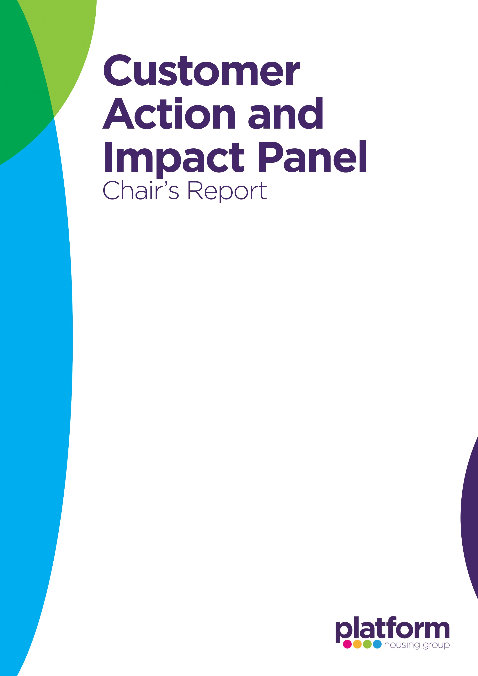
Date of Meeting | 23 April 2026

Topics Discussed & Presenter
Recruitment Update – Customer Voice Panel – Lisa Fairlie, Director of Housing Operations
Social Value Framework Update - Lianne Taylor, Director of Sustainability
Safeguarding Policies - Kath Dawson, Domestic Abuse and Safeguarding Manager
Develop questions for Ministry of Housing, Communities & Local Government Panel (MHCLG) – Engagement Preparation – Customer Voice Panel

Observations, Recommendations & Actions
Recruitment Update
The Panel noted strong interest in joining the Customer Voice Panel from across Platform's operating areas. The recruitment process was recognised as being robust, inclusive and focused on achieving appropriate representation across geography, protected characteristics and skills. Panel members supported the decision to pause recruitment in order to assess applications against identified representation gaps rather than making appointments prematurely.
Recommendations and Actions
- Continue monitoring representation gaps and use customer profile data to support a diverse and representative panel membership.
- Maintain proactive communication with applicants throughout the extended recruitment process to sustain engagement and transparency.

Social Value Framework
Members welcomed progress in developing the Social Value Framework and the extensive engagement undertaken with customers, colleagues and suppliers. The proposed priority themes of Cost of Living, Thriving Communities, and Employment & Skills Development were considered relevant and meaningful for customers.
Members sought assurance that supplier contributions would be varied and balanced, avoiding duplication of activity across providers. There was also interest in ensuring environmental benefits remain visible alongside social outcomes.
The Panel expressed support for the introduction of Social Value Champions and highlighted the importance of customer involvement in monitoring delivery and impact.


Recommendations and Actions
- Establish clear guidance for suppliers to ensure a balanced range of social value activities across priority areas.
- Incorporate environmental outcomes as a clearly visible element of social value reporting and communications.
- Develop opportunities for customers to contribute to the monitoring and review of supplier social value commitments.

Safeguarding Policies
Members welcomed the review of safeguarding arrangements and the separation of Adult and Children Safeguarding Policies, recognising the benefits of clearer alignment with legislation and best practice.
The increasing volume of safeguarding cases emphasised the importance of effective policies, colleague training and partnership working.
Discussion focused on customer safety, confidentiality and support mechanisms. Panel members identified a need for greater clarity within policy documents regarding Platform's role in safeguarding and how customers who report concerns are protected.
The Panel received assurance regarding mandatory training, contractor safeguarding requirements, internal audits and positive external assurance outcomes.
Recommendations and Actions
- Strengthen policy wording to clearly explain Platform's safeguarding responsibilities and limitations as a non-statutory safeguarding partner.
- Enhance guidance within policies regarding confidentiality and the protections available to customers who raise safeguarding concerns.
- Continue promoting safeguarding awareness through regular colleague training, contractor engagement and assurance activity.
- Encourage ongoing customer involvement in policy review processes to ensure documents remain accessible and customer-focused.

Ministry of Housing, Communities & Local Government Panel Engagement Preparation
Members actively contributed to the development of questions for engagement sessions with shortlisted candidates and demonstrated a strong focus on accountability, complaint handling, customer influence and transparency within the housing sector.
The significant increase in Housing Ombudsman complaints reinforced members' interest in understanding how national housing bodies intend to drive improvements in landlord performance and customer outcomes.
Recommendations and Actions
Continue to champion the customer voice in discussions with external stakeholders and regulators.
Focus future engagement on complaint resolution, landlord accountability, customer influence and service improvement outcomes.

Chair’s Thoughts
The Panel demonstrated constructive challenge and engagement across all agenda items. Discussions reflected a strong focus on representation, customer influence, safeguarding, accountability and measurable social value outcomes. Members welcomed the progress being made in each area while identifying opportunities to strengthen transparency, customer involvement and continuous improvement.

